**Report from week 5 to week 8**

1. **I took the pictures while we were pulling apart the lathe machine in week 2. I sent them to rest of the group by email.**
2. **Picture of the lathe with their parts labelled**

Thiswas requested by John Vivian.

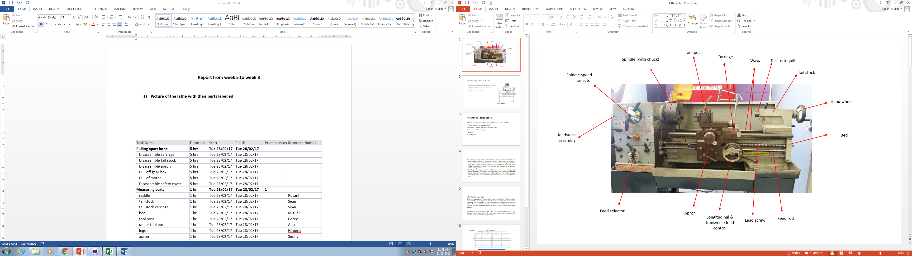

1. **While disarming the lathe, we took the measures of**

* Travel distance (max distance between centres): 550 mm (from Chuck to tail stock)
* Swing over carriage (max diameter): 105.70 mm
* Swing over bed: 161.10 mm
* Swing over the ways: 150.02 mm

All these, I submitted in GitHub for the record in a Power Point file.



1. **Drawing in Inventor the part I was assigned for:** saddle

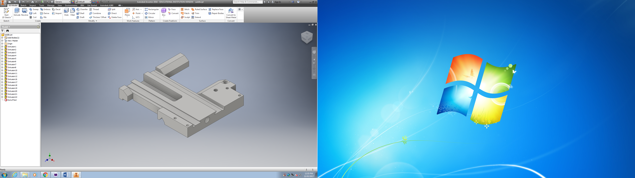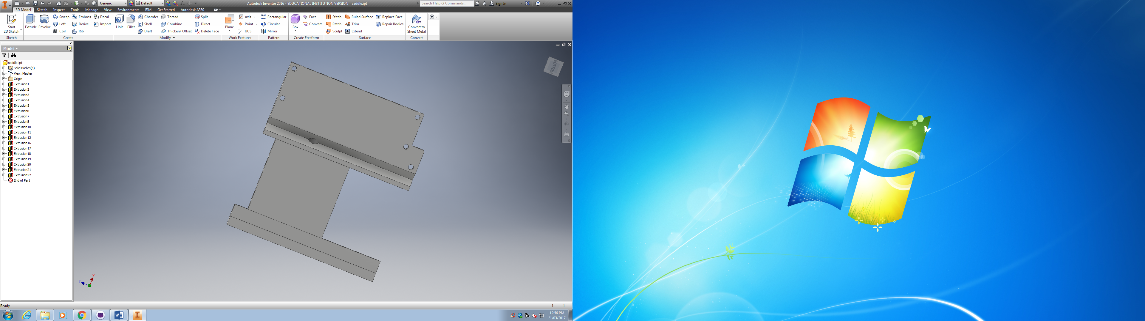

1. **I listed all the tasks involved in this project with the help of Microsoft Project, where I assigned estimated durations and dates to the task. As it can be seen in the following table, there is a column named Resource Names, which specified the people in charge of each task. Finally, Project was useful to generate the Gantt chart as well.**

|  |  |  |  |  |  |
| --- | --- | --- | --- | --- | --- |
| Task Name | Duration | Start | Finish | Predecessors | Resource Names |
| **Pulling apart lathe** | **5 hrs** | **Tue 28/02/17** | **Tue 28/02/17** |  |  |
| Disassemble carriage | 5 hrs | Tue 28/02/17 | Tue 28/02/17 |  |  |
| Disassemble tail stock | 5 hrs | Tue 28/02/17 | Tue 28/02/17 |  |  |
| Disassemble apron | 5 hrs | Tue 28/02/17 | Tue 28/02/17 |  |  |
| Pull off gear box | 5 hrs | Tue 28/02/17 | Tue 28/02/17 |  |  |
| Pull of motor | 5 hrs | Tue 28/02/17 | Tue 28/02/17 |  |  |
| Disassemble safety cover | 5 hrs | Tue 28/02/17 | Tue 28/02/17 |  |  |
| **Measuring parts** | **1 hr** | **Tue 28/02/17** | **Tue 28/02/17** | **1** |  |
| saddle | 1 hr | Tue 28/02/17 | Tue 28/02/17 |  | Rosani |
| tail stock | 1 hr | Tue 28/02/17 | Tue 28/02/17 |  | Sean |
| tail stock carriage | 1 hr | Tue 28/02/17 | Tue 28/02/17 |  | Sean |
| bed | 1 hr | Tue 28/02/17 | Tue 28/02/17 |  | Miguel |
| tool post | 1 hr | Tue 28/02/17 | Tue 28/02/17 |  | Corey |
| under tool post | 1 hr | Tue 28/02/17 | Tue 28/02/17 |  | Alex |
| legs | 1 hr | Tue 28/02/17 | Tue 28/02/17 |  | Nimesh |
| apron | 1 hr | Tue 28/02/17 | Tue 28/02/17 |  | Sunny |
| gear box | 1 hr | Tue 28/02/17 | Tue 28/02/17 |  | Tran |
| chuck | 1 hr | Tue 28/02/17 | Tue 28/02/17 |  | Sundeep |
| **Drawing parts in Inventor** | **23 hrs** | **Wed 1/03/17** | **Fri 3/03/17** | **8** |  |
| saddle | **23 hrs** | Wed 1/03/17 | Fri 3/03/17 |  | Rosani |
| tail stock | **23 hrs** | Wed 1/03/17 | Fri 3/03/17 |  | Sean |
| tail stock carriage | **23 hrs** | Wed 1/03/17 | Fri 3/03/17 |  | Sean |
| bed | **23 hrs** | Wed 1/03/17 | Fri 3/03/17 |  | Miguel |
| tool post | **23 hrs** | Wed 1/03/17 | Fri 3/03/17 |  | Corey |
| under tool post | **23 hrs** | Wed 1/03/17 | Fri 3/03/17 |  | Alex |
| legs | **23 hrs** | Wed 1/03/17 | Fri 3/03/17 |  | Nimesh |
| apron | **23 hrs** | Wed 1/03/17 | Fri 3/03/17 |  | Sunny |
| gear box | **23 hrs** | Wed 1/03/17 | Fri 3/03/17 |  | Tran |
| chuck | **23 hrs** | Wed 1/03/17 | Fri 3/03/17 |  | Sundeep |
| **Searching information and selection** | **286 hrs** | **Tue 7/03/17** | **Tue 25/04/17** |  |  |
| Forces, speed, power | 6 hrs? | Tue 7/03/17 | Tue 7/03/17 |  | Alex,Corey,Miguel |
| Ball screws | 6 hrs? | Tue 7/03/17 | Wed 8/03/17 | 31 | Alex,Rosani,Sean |
| Servo motors | 6 hrs? | Wed 8/03/17 | Thu 9/03/17 | 32 | Sunny,Corey |
| Cutting tools | 6 hrs? | Tue 7/03/17 | Tue 7/03/17 |  | Alex,Rosani,Sean |
| Wiring diagram | 6 hrs? | Thu 9/03/17 | Fri 10/03/17 | 33 | Nimesh,Sundeep,Sunny |
| Power board | 6 hrs? | Fri 10/03/17 | Fri 10/03/17 | 35 | Nimesh,Sundeep,Sunny |
| Encoder | 18 hrs? | Tue 7/03/17 | Thu 9/03/17 |  | Nimesh |
| Sensors | 6 hrs? | Fri 10/03/17 | Fri 10/03/17 | 35 | Sundeep |
| **Monitoring** | **30 hrs** | **Tue 7/03/17** | **Fri 10/03/17** |  |  |
| **Safety** |  | **Tue 7/03/17** |  |  |  |
| End stops |  | **Tue 7/03/17** |  |  | Sundeep |
| Homing sensors |  | **Tue 7/03/17** |  |  | Sundeep |
| Encoder |  | **Tue 7/03/17** |  |  | Nimesh |
| **Mechanical axis of motion** |  | **Tue 7/03/17** |  |  |  |
| **Feed rate** |  | **Tue 7/03/17** |  |  | **Miguel** |
| Ball screws-longitudinal Z |  | **Tue 7/03/17** |  |  |  |
| Cutting tool - across X |  | **Tue 7/03/17** |  |  |  |
| Spindle turning |  | **Tue 7/03/17** |  |  |  |
| **Motors** |  | **Tue 7/03/17** |  |  | **Sunny** |
| Forces |  | **Tue 7/03/17** |  |  |  |
| Control |  | **Tue 7/03/17** |  |  |  |
| Voltage |  | **Tue 7/03/17** |  |  |  |
| Making the shopping list | 6 hrs? | Wed 26/04/17 | Wed 26/04/17 | 30 | Corey |
| **Waiting for delivery of parts** | **8 hrs?** | **Wed 26/04/17** | **Thu 27/04/17** | **53** |  |
| Designing supports of the screws, motors and sensors | 486 hrs? | Tue 7/03/17 | Tue 30/05/17 |  | Alex,Rosani,Sean |
| Designing protector cover for lathe | 6 hrs? | Tue 7/03/17 | Tue 7/03/17 |  |  |
| Cleaning lathe | 6 hrs? | Wed 31/05/17 | Wed 31/05/17 |  |  |
| Painting lathe | 6 hrs? | Wed 31/05/17 | Thu 1/06/17 | 64 |  |
| Installing new parts | 30 hrs? | Thu 1/06/17 | Tue 6/06/17 | 54 |  |
| Electrical connections and installation | 30 hrs? | Thu 1/06/17 | Tue 6/06/17 | 54 |  |
| Installing cover | 6 hrs? | Tue 6/06/17 | Wed 7/06/17 | 67 |  |

The resources are listed first in the resource sheet and then are assigned to each task.

GANTT CHART













1. Program excel spread sheet with the formulas to calculate the cutting force, the correction factor and the machine power requirement. This file is in GitHub.

In the cutting forces sheet, we just need to introduce the depth of cut (a) and the feed (s) to obtain the Tangential cutting force (Ft) and then introduce it in the assigned box as well as the chip area (A) to obtain the initial correction factor (Ks initial).

Cutting forces sheet



$$ks=\frac{Ft}{A}$$

$$Ft=ks x a x s$$

Power requirement sheet

$$P= \frac{v x a x s x ks}{ɳ x 60 x1000}$$

$$P=\frac{v x Ft}{ɳ x 60 x 1000}$$

$$Pnet=\frac{v x Ft}{60 x 1000}$$

$$P=\frac{Pnet}{ɳ}$$

Where:

|  |
| --- |
| P: available motor effect (kW) |
| Pnet: net effect for metal cutting (kW) |
| v: cutting speed (m/min) |
| a: depth of cut (mm) |
| s: feed (mm/r) |
| ks: specific cutting force (N/mm^2) |